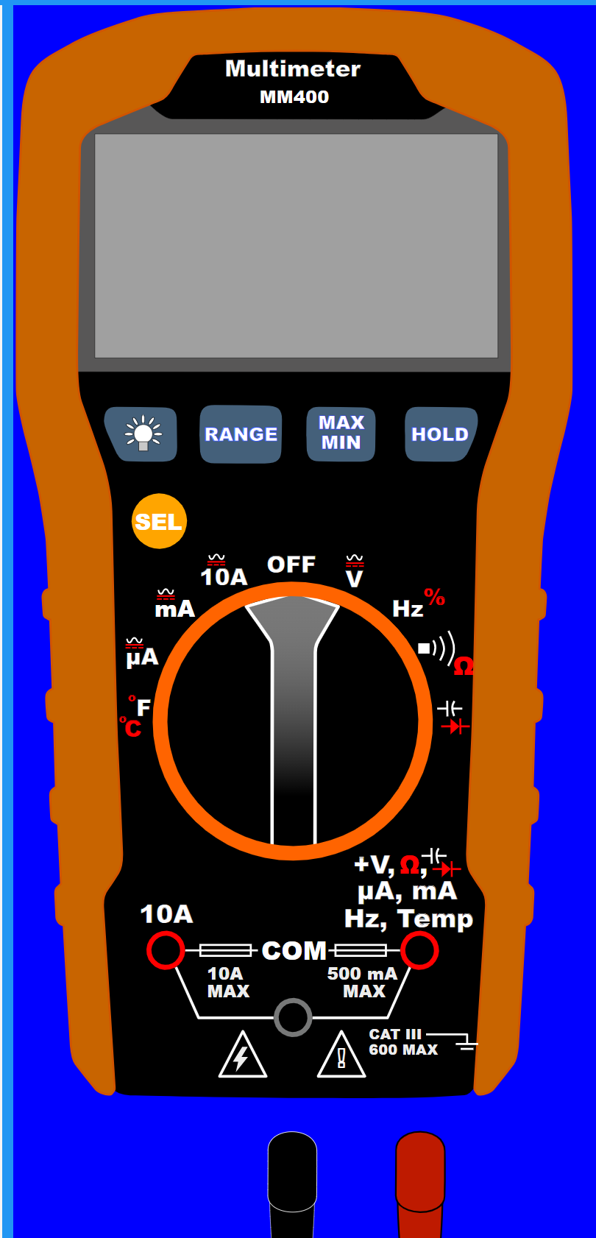
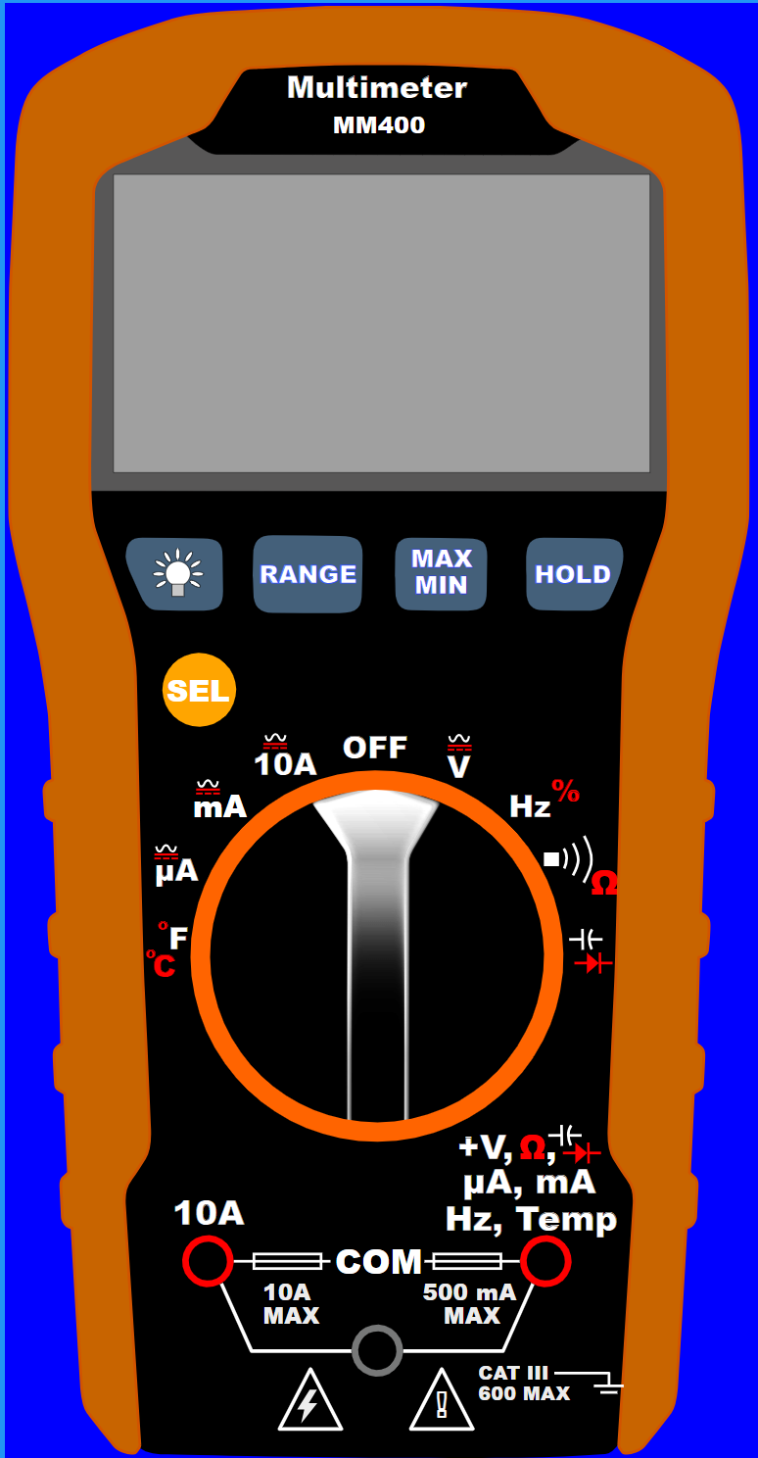

<linearGradient id="linearGradient32"> <filter style="color-interpolation-filters:sRGB"

http://127.0.0.1:5500/css/Education/training/media/imgs/low-noise-darker.png

